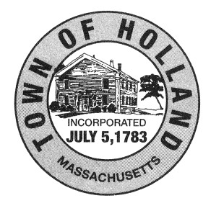

Holland Conservation Commission

Conservation Room, 2nd Floor
Town Hall
27 Sturbridge Road
Holland, MA 01521

The Meeting Scheduled for Tuesday,
July 11, 2023 at 6:30 pm

Has Been Cancelled

