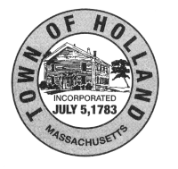
Holland Conservation Commission
Conservation Room, 2nd Fl
27 Sturbridge Road
Holland, MA 01521
Conservation@hollandma.org

Meeting Agenda for Tuesday, February 27th, 2024
THIS MEETING WILL BE RECORDED

6:30pm – Conservation Business

- Review of Agenda
- Approval - Minutes of all minutes that have not yet been reviewed.
- Review of Site Visits Since Last Meeting
- Plan Site Visits
- Review of Tree Removal Applications

7:00pm – Public Hearings:

1. DEP # 184–0440 - 15 Alexander Road- Utility work and tree removal.
2. DEP # 184–0442 - 36 Massaconnic Trail- Demo and rebuild house.
3. DEP # 184–0443 - 7 Waterfront Way- New deck.

This meeting will be held in person in the Community Room, 1st FL, or if unavailable, in the Conservation Room, 2nd FL in the Town Hall, 27 Sturbridge Rd, Holland, MA, and simultaneously via GoToMeeting. Please join the meeting from your computer, tablet or smartphone. https://www.gotomeet.me/JessicaChaffee You can also dial in using your phone: USA: +1 (224) 501-3412 / Access Code: 153-993-245

Respectfully submitted,
Jessica Wales

