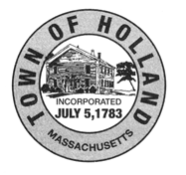
Town of Holland
Conservation Commission
27 Sturbridge Road, 2nd Floor
Holland, MA 01521
Meeting Minutes for January 23, 2024
NOTE: | This meeting has been canceled.

Next meeting:
Date: February 13, 2024
Time: 6:30 PM
Place: Conservation Room, 2nd Floor
Respectfully submitted,
Shannon Boyce
Recording Secretary

