,
Board of Selectmen
27 Sturbridge Road
Holland, MA 01521
413-245-7108 Ext. 101
Selectmen@hollandma.org

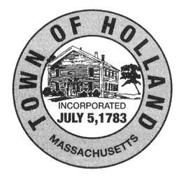 TOWN of HOLLAND
AUTOMOBILE CLASS I, II, III LICENSE Application
NOTE: General Business License Application also Required
COMPLETE ONE APPLICATION for EACH and ALL Business Entities on Premises
[ ] NEW LICENSE [ ] RENEWAL [ ] CHANGE TO EXISTING LICENSE
TYPE OF AUTOMOBILE LICENSE (check box): Class I □ Class II □ Class III □
Are you engaged principally in the business of buying, selling, or exchanging motor vehicles? (check box):
Yes □ No □
- If Yes, specify which applies: ___________________________________________________________
Are you a recognized agent of a motor vehicle manufacturer? (check box): Yes □ No □
- If Yes, state the name of the manufacturer: _________________________________________________
Have you signed a contract as required by CH 140 Sec 58 (ONLY for Class I): Yes □ No □
Have you ever applied for a license to deal in second hand motor vehicles or parts: Yes □ No □
- If Yes, in what city/town? _______________________________________________________________
Did you receive a license? (check box): Yes □ No □
- If Yes, What Year(s)? __________________________________________________________________

Has any licensed issued to you in MA or any other state to deal in motor vehicles or parts ever been suspended
or revoked? (check box): Yes □ No □
- If Yes, please provide reason: _____________________________________________________________

I, the undersigned, duly authorize by the concern herein mentioned, hereby apply for a Class _____ License, to Buy, Sell, Exchange or Assemble secondhand motor vehicles or part thereof, in accordance with the provisions of Chapter 140 of the General Laws.
Signature: ___________________________________ Dated: ____________________

For Official Use Only
POLICE APPROVAL
Signature: ___________________________________ Dated: ____________________

BOARD OF SELECTMAN ACTION: APPROVED □ REJECTED □
Signature: ___________________________________ Dated: ____________________

Signature: ___________________________________ Dated: ____________________

Signature: ___________________________________ Dated: ____________________
Notes:

