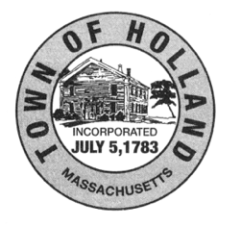
Board of Selectmen
27 Sturbridge Road
Holland, MA 01521
413-245-7108 Ext. 101
Selectmen@hollandma.org

TOWN of HOLLAND
APPLICATION FOR COMMON VICTUALLER LICENSE
NOTE: General Business License Application is also Required
APPLICANT/BUSINESS INFORMATION:

Applicant Name: ___________________________________

Business Name: ____________________________________

Business Address: ________________________________________________________________________________

_______________________________________________________________________________________________

Please list all other licenses you have for this business: ___________________________________________________

Do you allow “Bring your Own Bottle” (BYOB) at this establishment: _________________________________________

If yes, please describe area where alcoholic beverage consumption will be allowed: ____________________________

Responsible Manager: Age: Phone #____________________________

_______________________________________________________________________________________________
Note: The applicant/licensee acknowledges and assents to participation in any Holland Police Dept. “Sting” operations as conducted for establishments licensed to serve alcohol. Applicant/licensee agrees that any on-site manager shall be at least 18 years of age.

List any applicable Permit Conditions:

I, the undersigned, state that the information provided in this application, and associated attachments, is true and accurate to the best of my knowledge.

Signature: __________________________________________________ Dated: ___________________________________________

For Official Use Only
BOARD OF SELECTMEN ACTION: APPROVED: REJECTED:
Signature: _______________________________________ Dated:___________________________________

Signature: _______________________________________ Dated:___________________________________

Signature: _______________________________________ Dated:___________________________________

