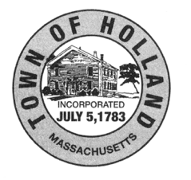
Board of Selectmen
27 Sturbridge Road
Holland, MA 01521
413-245-7108 Ext. 101
Selectmen@hollandma.org

TOWN of HOLLAND
APPLICATION FOR ENTERTAINMENT LICENSE/PERMIT
NOTE: General Business License Application is also Required

Applicant's Name: _______________________________

Applicant's Address: ______________________________

Business Name: __________________________________
Business Address: ________________________________

Description of proposed entertainment: ____________________________________________________________
_____________________________________________________________________________________________
Description of Plan for Safety/Nuisance Mitigation: (Use additional sheets if needed) _______________________
_____________________________________________________________________________________________
Days/Hours of Entertainment: _____________________________________________________________________
Note: Sunday requires separate MA Department of Public Safety LICENSE For Sunday Public Entertainment (Form 90)
_______________________________________________________________________________________________
Applicant Signature(s):
Signature: _______________________________________ Dated:___________________________________

Signature: _______________________________________ Dated:_____________________________________

For Official Use Only
BOARD OF SELECTMEN ACTION: APPROVED: REJECTED:

Conditions (if any): ___________________________________________________________________________
___________________________________________________________________________________________

Signature: _______________________________________ Dated:___________________________________

Signature: _______________________________________ Dated:___________________________________

Signature: _______________________________________ Dated:___________________________________

Notes:

